Debugging Assignment

Q1.

#include int main() {

int a,b;

int c=a+b;

printf("%d",c); // Output: 5

return 0;

}

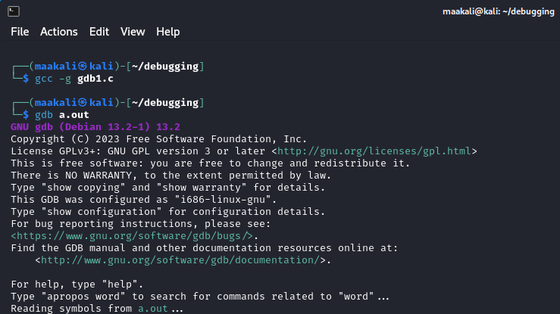

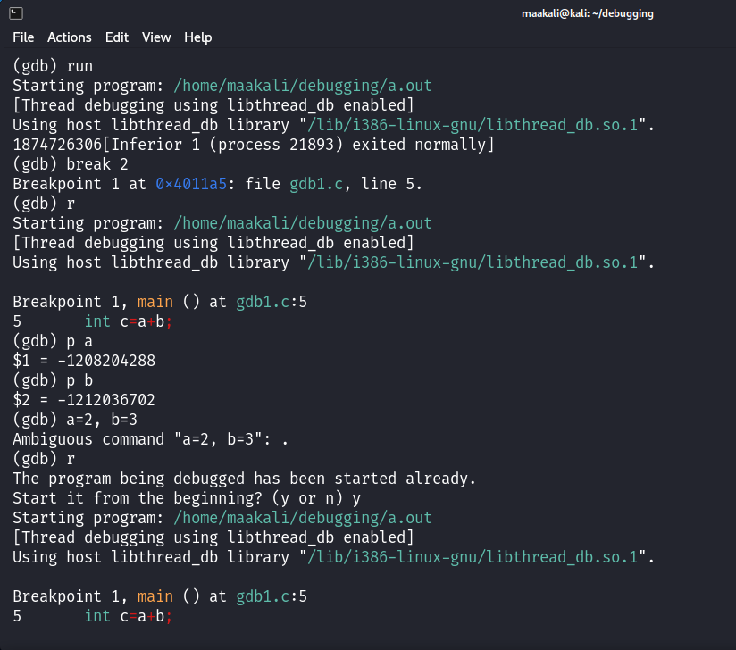

Q.2)

#include int main() {

int d=2;

printf("Enter the value of d:");

scanf("%d",d);

printf("The value of d is:%d",d);

return 0;

}

Correct code

#include <stdio.h>

int main()

{

int d=2;

printf("Enter the value of d:");

scanf("%d",&d);

printf("The value of d is:%d",d);

return 0;

}

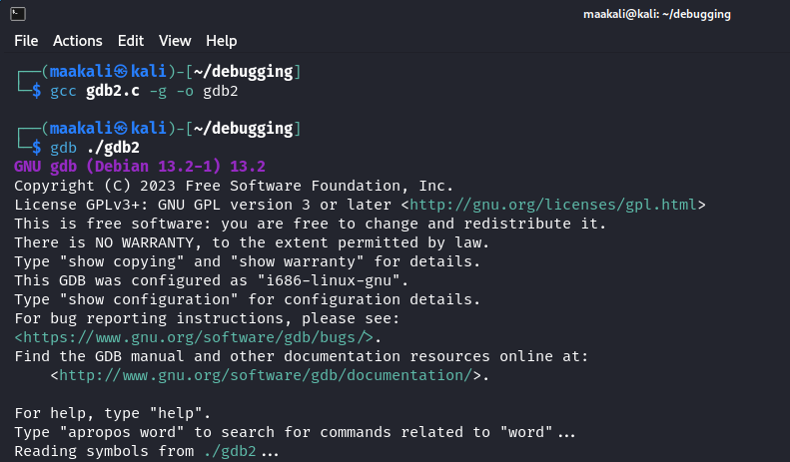

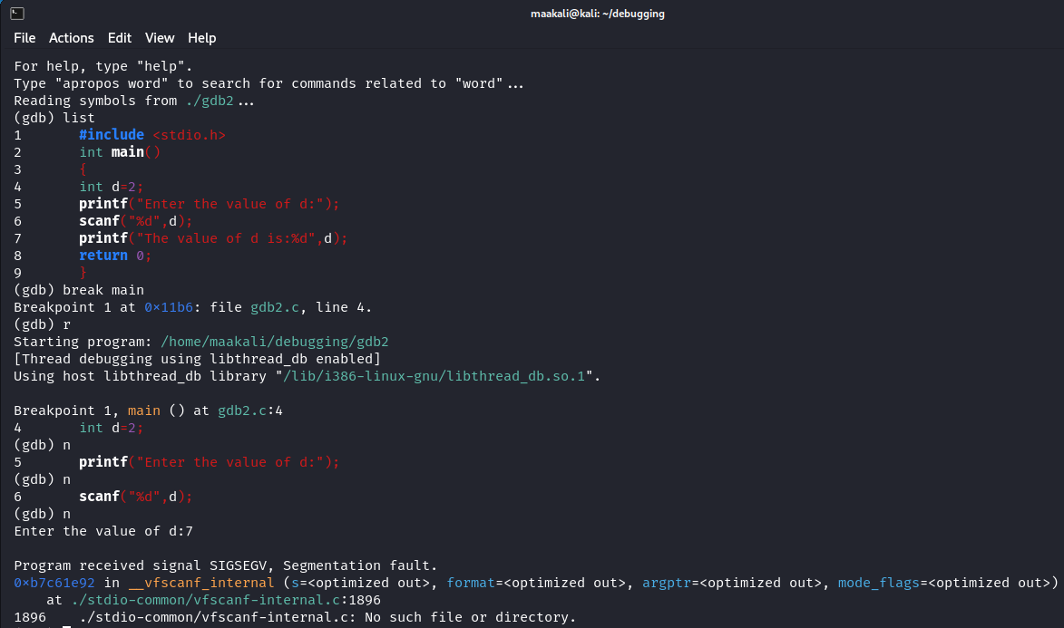

Q.3)

#include <stdio.h>

#include <stdlib.h>

int factorial(int n);

int main(void) {

int n = 5;

int f = factorial(n);

printf("The factorial of %d is %d.\n", n, f); n = 17;

f = factorial(n);

printf("The factorial of %d is %d.\n", n, f); return 0;

}

//A factorial is calculated by n! = n * (n - 1) * (n - 2) * ... * 1 //E.g. 5! = 5 * 4 * 3 * 2 * 1 = 120

int factorial(int n)

{ int f = 1; int i = 1;

while (i <= n) { f = f * i; i++; }

return f;

}

Correct code Q.3

#include <stdio.h>

#include <stdlib.h>

long long int factorial(int n);

int main(void) {

int n = 5;

long long int f = factorial(n);

printf("The factorial of %d is %lld.\n", n, f);

n = 17;

f = factorial(n);

printf("The factorial of %d is %lld.\n", n, f);

return 0;

}

//A factorial is calculated by n! = n * (n - 1) * (n - 2) * ... * 1

//E.g. 5! = 5 * 4 * 3 * 2 * 1 = 120

long long int factorial(int n) {

long long int f = 1;

int i = 1;

while (i <= n) {

f = f * i;

i++;

}

return f;

}

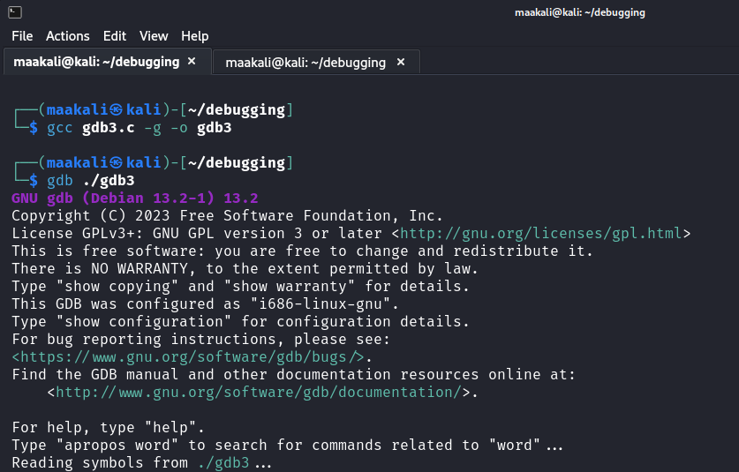

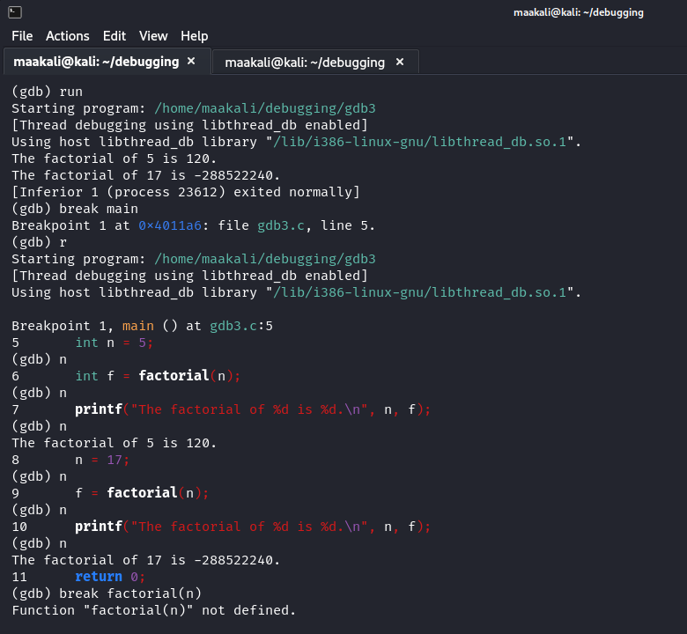

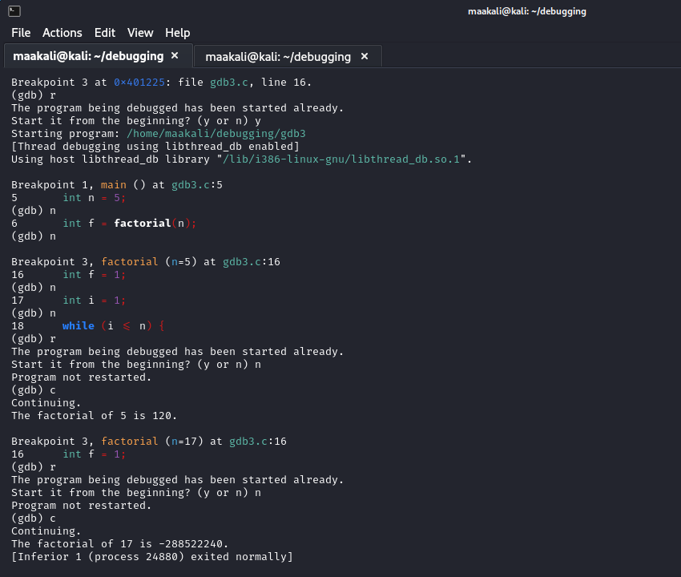

**Q.4)**

#include <stdio.h>

int main(void) {

int arr[2];

arr[3] = 10; // Accessing out of bound

return (0);

}

Correct code for Q.4):-

#include <stdio.h>

int main(void) {

int arr[4];

arr[3] = 10;

return (0);

}

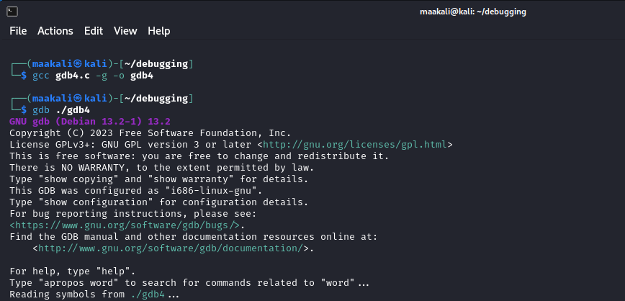

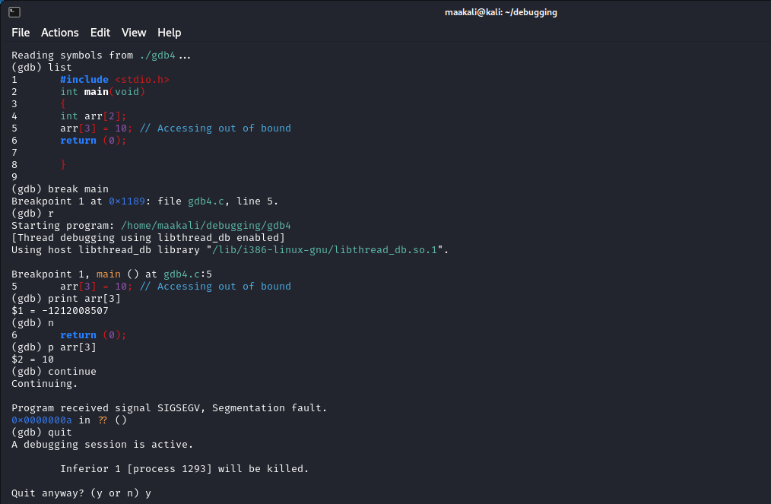

**Q.5)**

#include <stdio.h>

int main(){

int *p;

printf("%d",*p);

return 0;

}

Correct code Q.5):-

#include <stdio.h>

int main()

{

int *p;

int var = 15;

p = &var;

printf("%d",*p);

return 0;

}

